# User manual for Contacting Student and Companies to request additional data for the approval/rejection decision

This feature has been created in order to allow the placement tutor to contact the student and/or the company through the use of 2 different forms a “Contact Student” form, and a “Contact Company” form. Both forms follow the same structure, but differ in the pre-set text given to help the user form the email.

The below image shows the “Contact Student” Form and the “Contact Company (Placement Provider)” form (They have been zoomed out so we can see all the features in one page):

There are 3 fields “Email to”, “Subject and “Body”. The user can click on the input boxes and start typing the respective details in the boxes.

The pre-set information shown in the form’s fields helps to guide the placement tutor in forming the emails by providing email content for them, to help make the process quicker. In the text, where squared brackets are used, and where there is the gap in the body field, this means the user is suggested to enter specific details to personalise the email and make it more targeted in its communication purpose.

When the user is happy with the content in the fields (or the lack of field data is fine, as the user may want to go directly to the email client and fill out the content there), the user has 2 buttons to select: a submit button, and a redirect button. If the user clicks Submit, their default email client email will open, where they will be able to view the email in the email client:

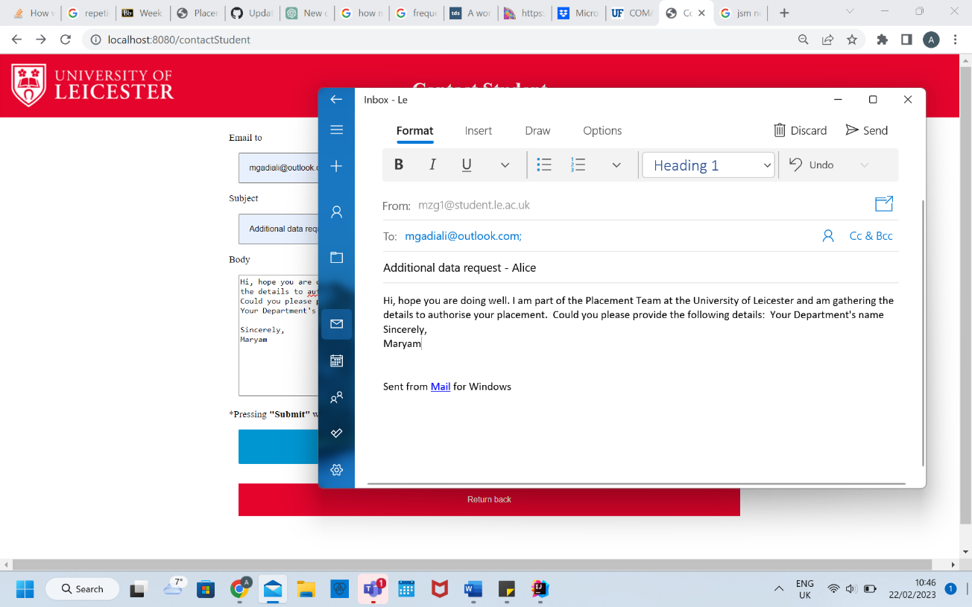

As you can see, the information we entered in the form automatically fills in the fields in the email client. So the placement tutor can further modify the content in the email client if they wish, and then they click the Send butter to send the email off.

When the user goes back to the page, they can see that there was also another button under the Submit button, which is a redirect feature to redirect the Placement tutor back to the table page showing students that are currently waiting for placement authorisation. Graphical user interface, application

Redirect button